Task 5.17.1 – Desktop Evaluations

Subtask 5 – Data-Driven Model Optimization for Chloramine and Anti-Scalant Dosing

* **Budget Spent through December 31**
  + Cumulative working hours total 100 hours
    - Yasuhiro Matsui (Project Lead): 7 hours
    - Kenichi Kamada (Data Analysis): 3 hours
    - Mika Kawata (Data Analysis): 20 hours
    - Wataru Kumagai (Data Analysis): 30 hours
    - Ryouko Imoto (Data Analysis): 40 hours
* **Summary of work complemented**

Data analytical policy was developed for the objective of operational optimization in terms of chloramine control and anti-scalant dosing rate. There are three considerations in the model creation in the Task 5.17.1.5 DDMO:

* Water qualities in the RO feed and permeate,
* Clogging status of RO membrane (monitoring the clogging),
* Deterioration of RO membrane (the life extension).

We focus our analysis on the behavior of RO membrane independently from UF membrane and UV/AOP processes in the gray area of Figure 1. First, we analyzed the acid dosage in the RO feed, the response of the electrical conductivity, TOC and other water quality parameters in the RO permeate, and the RO permeate flow rate shown in yellow. The scope of analysis will be expanded in stepwise. Learn the hourly and/or daily conditions and fluctuations and the impact on RO membrane performance, followed by analysis of whether anti-scalant dosage rate, as well as Cleaning in Place (CIP) conditions, affect the RO membrane performance and the membrane clogging status. The RO permeate flow rate and water quality, RO membrane clogging status, and the membrane life, which are the target effects brought by the optimization. However, differs from short, medium and long term, respectively, when these effects become apparent.

The historical data of both Las Virgenes Municipal Water District (LVWMD) and Orange County Water District (OCWD) were provided in November. We inquired about the RO process and the data for data analysis.

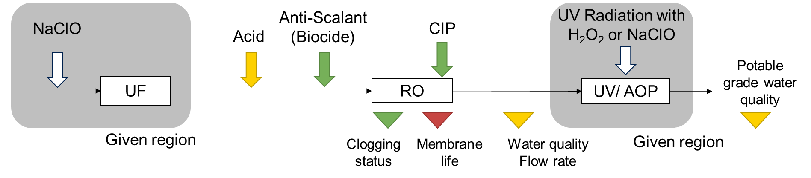

Figure 1. Highlighted values based on the analysis policy

* **Reference 1: Desktop Evaluation based on OCWD Data**

RO system in OCWD is a full-scale plant and consists of 21 systems (3 units x 7 trains) with 5 MGD capacity per each unit. As OCWD reported in the Figure 2, these 21 systems with different start-up and operated now.

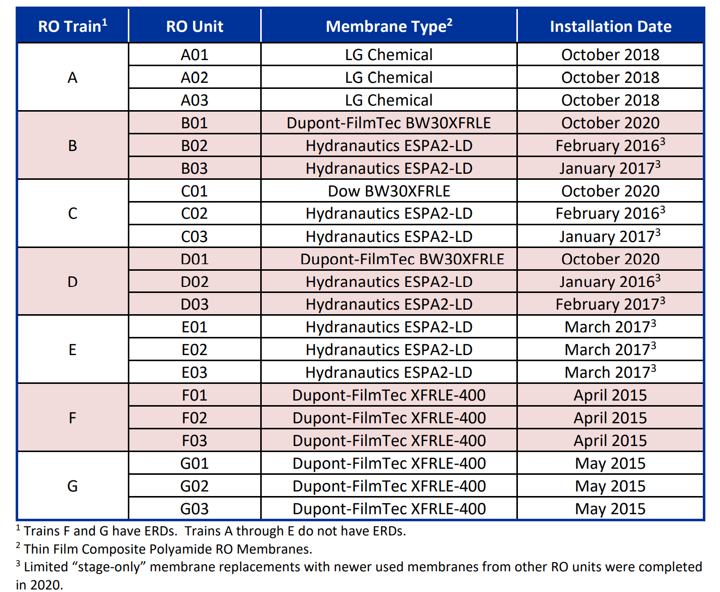

Figure 2. 2021 Annual Report by OCWD’s Groundwater replenishment System

All units are 3-stages configuration as shown in the Figure 3. Three different brands (Dupont-FilmTec, Hydranautics, LG) and 4 different RO elements (XFRLE-400, ESPA2-LD, BW30XFRLE, LG Chemical).

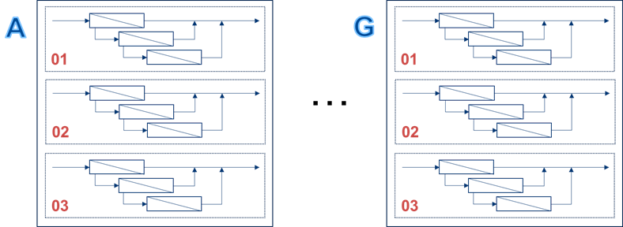

Figure 3. RO System with 3 Stages and Process in OCDW

The data of pressures measured at RO feed and permeate provided by OCWD, included data circled in red boxes and given by calculation in the blue boxes as shown in Figure 4. However, since we are planning to create an AI model to express the relationships among parameters, we need to learn long-term data more than 1 year and missing data such as flow rates and electric conductivities at RO permeate and concentrate, respectively as shown white boxes in Figure 4. We are requesting to OCWD to provide additional data from DoPont-FilmTec XFRLE-400, which should be most edged due to the earliest installation in 2015.

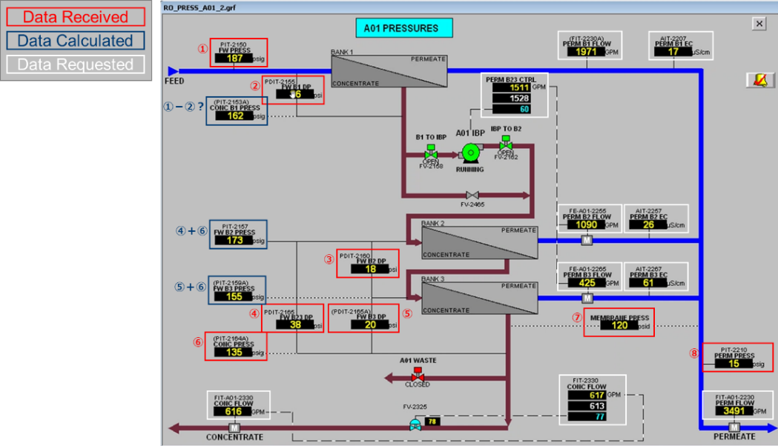

Figure 4. HMI Graphic in the RO System

* **Reference 2: Desktop Evaluation based on LVMWD Data**

RO system in the pilot plant of the Pure Water Project by LVMWD consists of 3 Stages configuration and Toray’s TM720-370 is deployed. Three years of data since 2020 are available, which include pressure, flow rate, conductivity, TOC, and other parameters as indicted in Figure 5. Provided minute interval data were converted to daily trends to understand fluctuations and behaviors. And as a first step, we analyzed the data focused on differential pressure per each pressure vessel (DP), TOC removal, conductivity, and the relationship between feed pressure and permeate conductivity of the 1st Stage of RO.

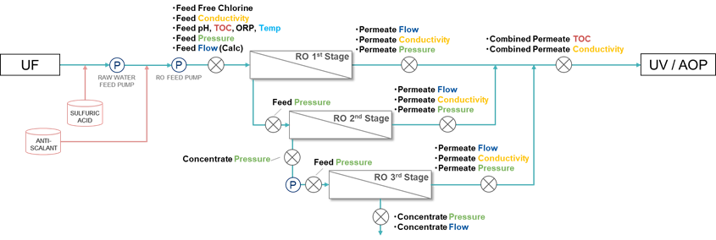

Figure 5. RO System in LVMWD

In Figure 6 to 8, DP trends based on available data from 2021 seem to change before and after the maintenance event like CIP. However, information is not clear to identify the event, probably CIP event, should be clarified. While the CIP interval, DP decay is limited in 0.1 psi/month, 1.5%/month based on 2022 data. The DP is calculated by the formula as below.

1) 1st Stage DP = 1st Stage Feed Pressure – 2nd Stage Feed Pressure

2) 2nd Stage DP = 2nd Stage Feed Pressure – 2nd Stage Concentrate Pressure

3) 3rd Stage DP = 3rd Stage Feed Pressure – 3rd Stage Concentrate Pressure

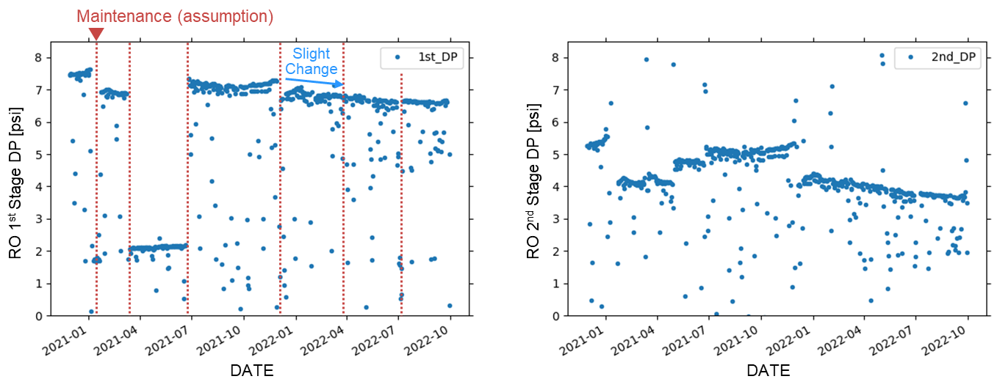

Figure 6. DP in the 1st Stage Figure 7. DP in the 2nd Stage RO

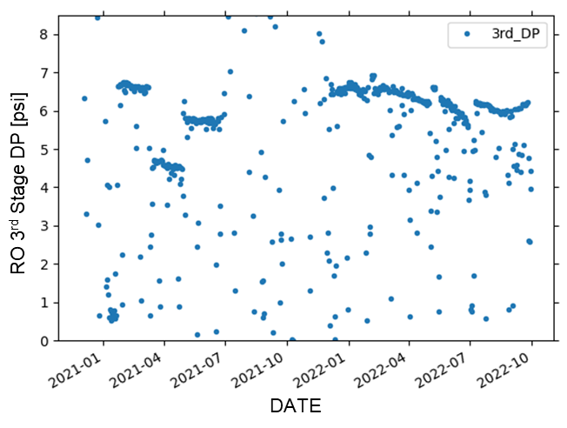

Figure 8. DP in the 3rd Stage

In Figure 9, the TOC removal rates based on data available since 2021 were approximately 98.89 ± 0.95%. The data below 99% were also scattered, and the reason and necessity of verification are not clear. We need to clarify. The TOC removal rate is given by the formula as below.



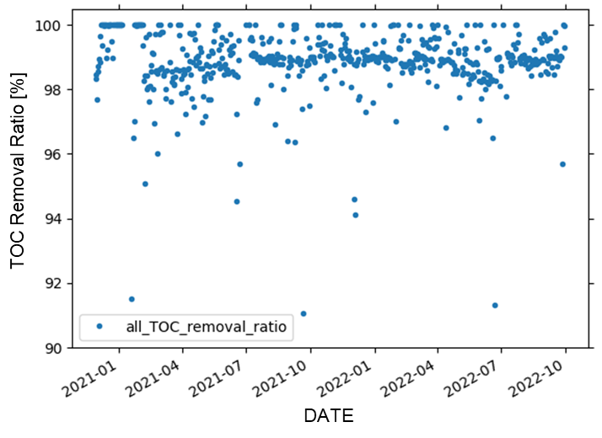

Figure 9. TOC Removal Rate

As shown in Figure 10 to 12, RO permeate conductivity trends based on available data from 2021 turned to significant increase after June 2022. The RO 1st Stage feed conductivity was stable at 1,200 uS/cm (Figure 13). To confirm a quantitative rate of the increase, we calculated the daily differential fluctuation from 1st Stage Permeate to 3rd Stage based on 2022 behaviors, which are shown in Figure 14 to 16. These trends suggest the possibility that RO clogging is progressing, and subsequent behaviors should be monitored.

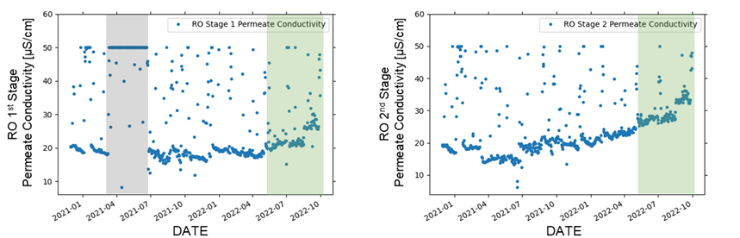

Figure 10. 1st Stage Permeate Conductivity Figure 11. 2nd Stage Permeate Conductivity

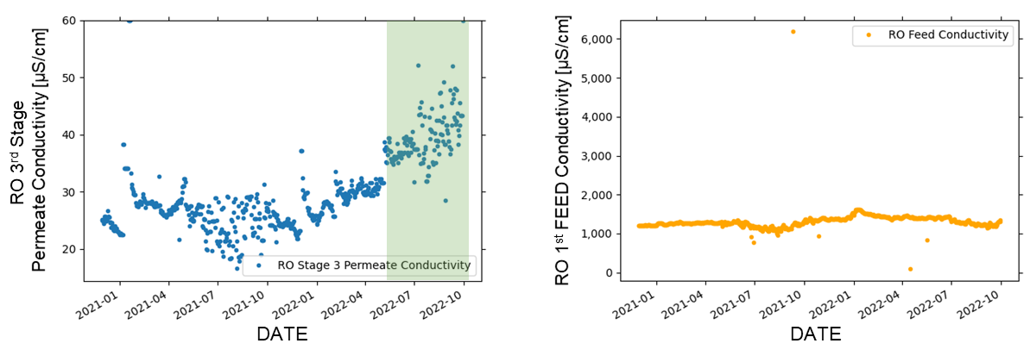

Figure 12. 3rd Stage Permeate Conductivity Figure 13. RO Feed Conductivity

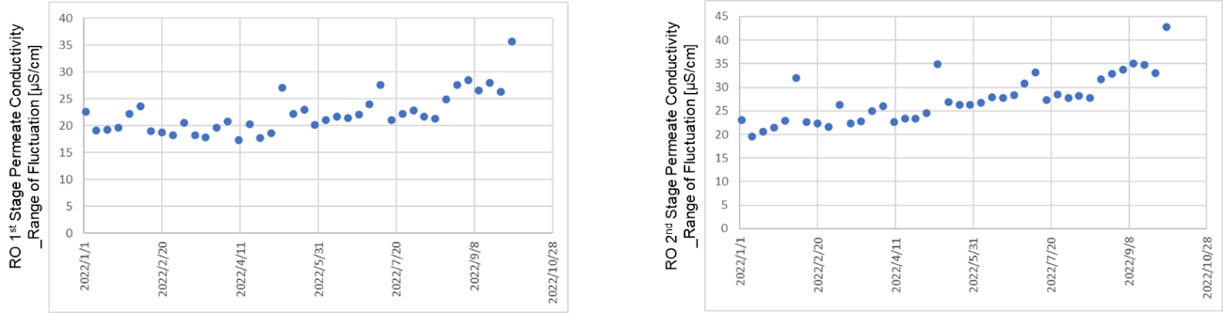

Figure 14. 1st Stage Permeate Daily Fluctuation (left), Figure 15. 2nd Stage Permeate Daily Fluctuation (right)

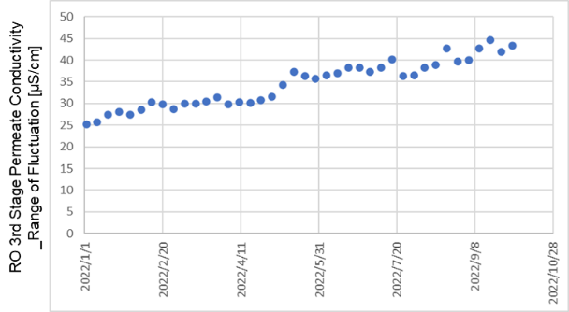

Figure 16. 3rd Stage Permeate Daily Fluctuation

In Figure 17, the correlation between RO 1st Stage Feed Pressure and RO 1st Stage Permeate Conductivity based on available data from April to July 2022 is negative. It matches the theoretical behavior of RO.

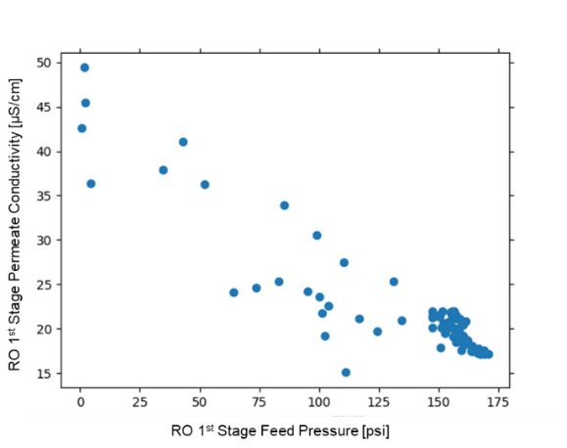

Figure 17. Scatter Diagram of 1st Stage Feed Pressure and 1st Stage Permeate Conductivity

* **Future Tasks**

In the data analysis, we will verify temperature conversion and the impact on the evaluation. We did not receive data nor information related to chemical dosage. We carry out the chemical influences on the RO operation through the data analysis.

In the model creation, continue to select target variables related to the RO optimization. We verify whether the AI model can predict the RO permeate flow rate and water quality. We analyze the behavior of the salt rejection for driving pressure at each stages from 1st to 3rd and explore the optimal operation within the operational range recommended by membrane suppliers.